GVT Experiment log

Date: August 02 - 03, 2016
Aircraft: Geri (mAEwing1 CB3+WS4)

Experiment Details
2

Transducers
Force: PCB208C01 SN LW38483 500 mv/lb
Accel1: PCB353B16 SN172575 10.18 mV/g
Accel2: PCB353B16 SN101607 xx.xx mV/g
X
Y
Signal Conditions:
Force 10x
Accel1 100x
Accel2 100x

Point locations
20
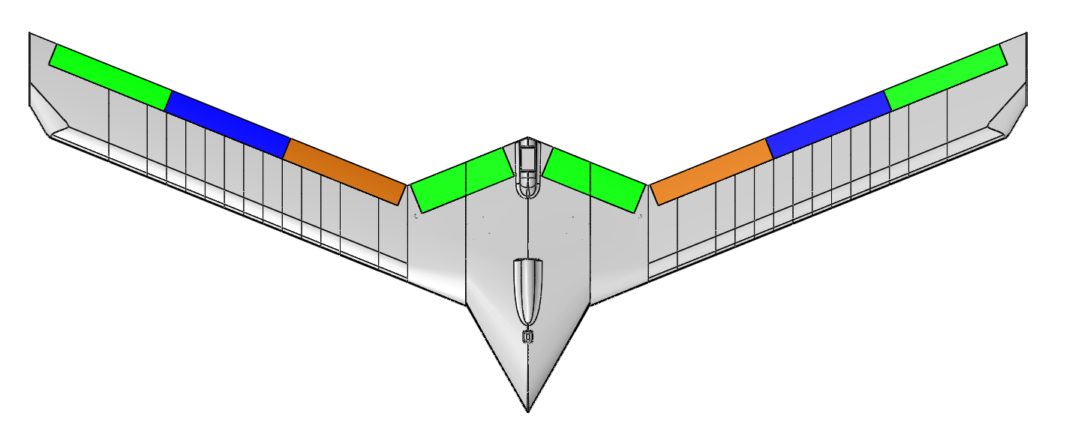
1
4
3
6
5
7
8
9
10
11
12
13
14
15
16
17
18
19
Point | X-Coordinate (in) | Y-Coordinate (in)
21 | 0.0 | 2.5 (front cover screw)
22 | 0.0 | 23.5 (aft of aft accel)
1 | 15.0 | 18.0
2 | 15.0 | 24.25
3 | 26.0 | 22.25
4 | 26.0 | 28.5
5 | 35.0 | 26.0
6 | 35.0 | 32.25
7 | 44.25 | 29.75
8 | 44.25 | 36.0
9 | 53.375 | 33.5
10 | 53.375 | 39.75
23 | 57.375 | 34.375 (front accel)
24 | 57.375 | 40.625 (aft accel)
25 | 59.75 | 46.0
11 | -15.0 | 18.0
12 | -15.0 | 24.25
13 | -26.0 | 22.5
14 | -26.0 | 28.75
15 | -35.0 | 26.25
16 | -35.0 | 32.5
17 | -44.25 | 29.75
18 | -44.25 | 36.0
19 | -53.375 | 33.5
20 | -53.375 | 39.75
26 | -57.375 | 34.5 (front accel)
27 | -57.375 | 40.875 (aft accel)
28 | -59.75 | 46.0

Excitation Location | X-Coordinate (in) | Y-Coordinate
1 (Symmetric) | 0.0 | 30.375
2 (Un-Symmetric) | -4.25 | 24.375

Run Details

Run # | Position: Force | Position: Accel 1 | Position: Accel 2
1 | 1 (Symmetric) | 1 | 11
2 | 1 (Symmetric) | 2 | 12
3 | 1 (Symmetric) | 3 | 13
4 | 1 (Symmetric) | 4 | 14
5 | 1 (Symmetric) | 5 | 15
6 | 1 (Symmetric) | 6 | 16
7 | 1 (Symmetric) | 7 | 17
8 | 1 (Symmetric) | 8 | 18
9 | 1 (Symmetric) | 9 | 19
10 | 1 (Symmetric) | 10 | 20
11 | 1 (Symmetric) | 23 | 26
12 | 1 (Symmetric) | 24 | 27
13 | 1 (Symmetric) | 25 | 28
14 | 1 (Symmetric) | 22 | 21
15 | 2 (Un-Symmetric) | 22 | 21
16 | 2 (Un-Symmetric) | 1 | 11
17 | 2 (Un-Symmetric) | 2 | 12
18 | 2 (Un-Symmetric) | 3 | 13
19 | 2 (Un-Symmetric) | 4 | 14
20 | 2 (Un-Symmetric) | 5 | 15
21 | 2 (Un-Symmetric) | 6 | 16
22 | 2 (Un-Symmetric) | 7 | 17
23 | 2 (Un-Symmetric) | 8 | 18
24 | 2 (Un-Symmetric) | 9 | 19
25 | 2 (Un-Symmetric) | 10 | 20
26 | 2 (Un-Symmetric) | 23 | 26
27 | 2 (Un-Symmetric) | 24 | 27
28 | 2 (Un-Symmetric) | 25 | 28

